EX  No:1A | SETTING UP PYTHON ENVIRONMENT AND  LIBRARIES – JUPYTER NOTEBOOK

AIM:
To configure Python, Jupyter Notebook and verify the installation of essential data analytics libraries using the Space Mission dataset.
PROCEDURE:
- Install Jupyter Notebook using the command pip install notebook.
- Create a new Python notebook and rename it appropriately.
- Import the required libraries such as NumPy, Pandas, and Matplotlib.
- Verify the successful installation of the libraries by checking their versions.
- Load the Space Mission Dataset (all_space_mission_launches.csv) using the Pandas read_csv() function.
- Display the first few records of the dataset to verify successful loading.
- Examine the dataset structure using functions like info(), shape, and describe().
- Perform basic NumPy operations to verify numerical computation capabilities.
- Generate a simple visualization using Matplotlib to ensure the plotting library is functioning correctly.
OUTPUT:
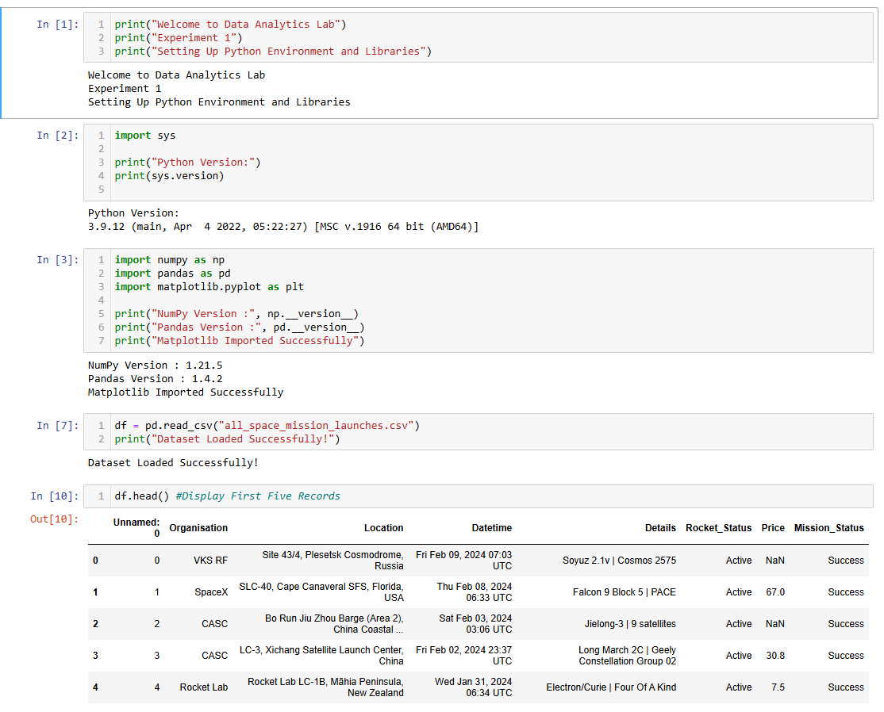
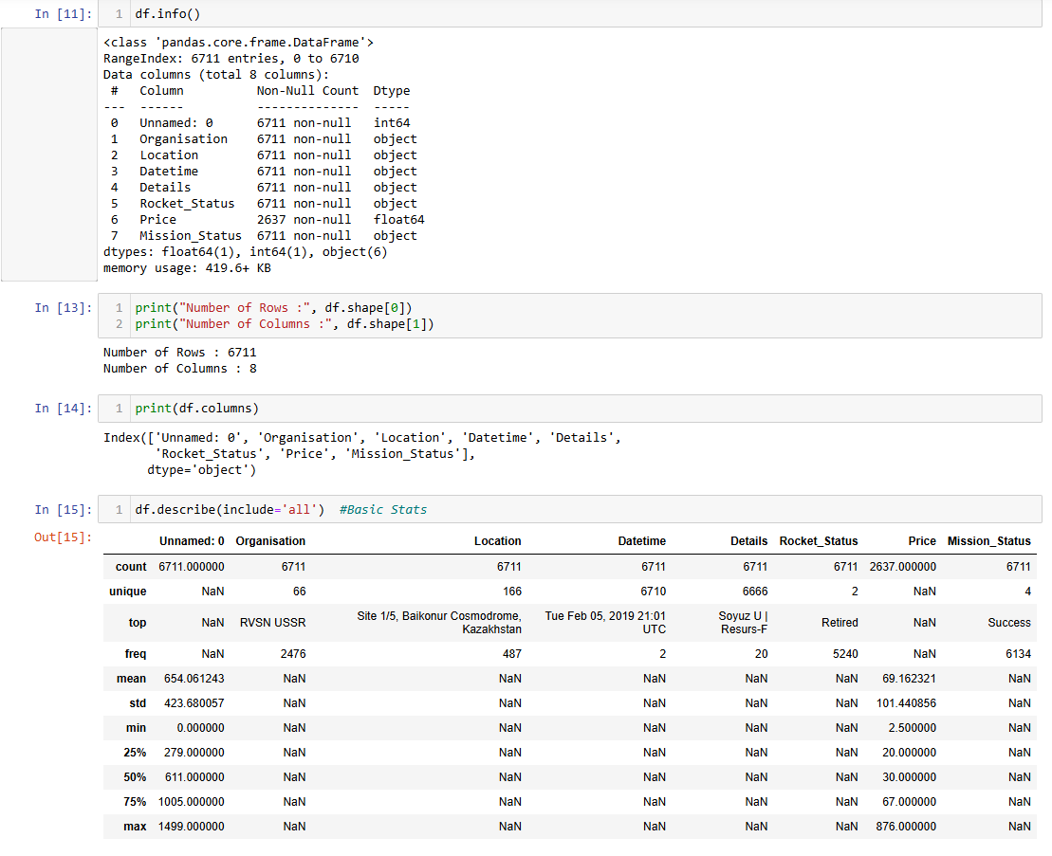
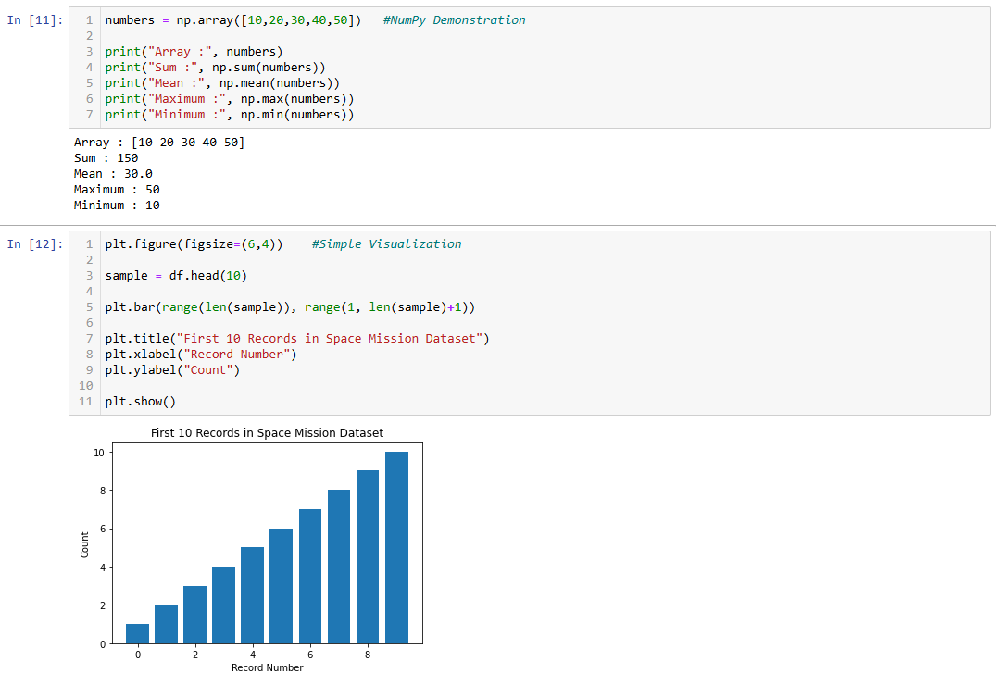
RESULT:
Thus, the Python environment and Jupyter Notebook were configured successfully, and the essential data analytics libraries were verified using the Space Mission dataset.

EXPT  NO:1B | SPACE MISSION LAUNCH SUCCESS  PREDICTION USING MACHINE LEARNING

AIM:
To analyze the Space Mission dataset (all_space_mission_launches.csv) using Exploratory Data Analysis (EDA), visualize the important launch patterns, preprocess the dataset, build a Machine Learning model to predict the mission status of a launch, evaluate the model and export the processed data to Excel.
PROCEDURE:
- Load the Space Mission dataset (all_space_mission_launches.csv) using Pandas.
- Import the required Python libraries such as Pandas, Matplotlib, Seaborn and Scikit-learn.
- Display the first few records, dataset shape, information and missing values.
- Remove the unnecessary index column (Unnamed: 0) and drop the duplicate records.
- Extract the launch country from the Location column and the launch year from the Datetime column.
- Convert the Price column to numeric and fill the missing values with the median price.
- Extract the rocket name from the Details column.
- Create the target variable Success from the Mission_Status column (1 for Success, 0 otherwise).
- Analyze the distribution of mission status, the top organisations and the top launch countries.
- Visualize the number of launches per year using a line plot.
- Visualize the mission success rate of the top 10 organisations using a bar chart.
- Encode the categorical features and separate the input features (X) and the target variable (y).
- Split the dataset into training and testing data in the ratio 80:20.
- Train a Random Forest Classifier using the training data.
- Predict the mission status for the test data.
- Evaluate the model using accuracy, classification report and confusion matrix.
- Display the feature importance obtained from the trained model.
- Export the processed Space Mission data to an Excel file and display the analysis result.
CODE:
import pandas as pd
import matplotlib.pyplot as plt
import seaborn as sns
from sklearn.model_selection import train_test_split
from sklearn.ensemble import RandomForestClassifier
from sklearn.metrics import accuracy_score, classification_report, confusion_matrix

# 1. Load dataset
df = pd.read_csv("all_space_mission_launches.csv")

# 2. Display dataset
print(df.head())

# 3. Dataset information
print("Shape:", df.shape)
print(df.info())

# 4. Check missing values
print(df.isnull().sum())

# 5. Remove unnecessary column
df = df.drop(columns=["Unnamed: 0"])

# 6. Remove duplicate records
df = df.drop_duplicates()

# 7. Feature engineering
df["Country"] = df["Location"].astype(str).str.split(",").str[-1].str.strip()
df["Year"] = df["Datetime"].astype(str).str.extract(r"(\d{4})").astype(float)
df["Price"] = pd.to_numeric(df["Price"], errors="coerce")
df["Price"] = df["Price"].fillna(df["Price"].median())
df["Rocket_Name"] = df["Details"].astype(str).str.split("|").str[0].str.strip()

# 8. Create the target variable
df = df.dropna(subset=["Mission_Status", "Year"])
df["Success"] = (df["Mission_Status"] == "Success").astype(int)
print("\nMission Status distribution:")
print(df["Mission_Status"].value_counts())
print("\nTop 10 Organisations:")
print(df["Organisation"].value_counts().head(10))
print("\nTop 10 Countries:")
print(df["Country"].value_counts().head(10))

# 9. Launches per year
plt.figure(figsize=(9, 4.5))
df["Year"].value_counts().sort_index().plot(kind="line", marker="o")
plt.title("Space Mission Launches per Year")
plt.xlabel("Year")
plt.ylabel("Number of Launches")
plt.grid(alpha=0.3)
plt.show()

# 10. Success rate of the top organisations
top = df["Organisation"].value_counts().head(10).index
rate = df[df["Organisation"].isin(top)].groupby(
"Organisation")["Success"].mean().sort_values()
plt.figure(figsize=(9, 4.5))
rate.plot(kind="barh", color="#4c72b0")
plt.title("Mission Success Rate - Top 10 Organisations")
plt.xlabel("Success Rate")
plt.show()

# 11. Encode the features
features = ["Organisation", "Country", "Rocket_Status", "Rocket_Name"]
X = df[features].apply(lambda c: c.astype("category").cat.codes)
X["Price"] = df["Price"].values
X["Year"] = df["Year"].values
y = df["Success"]

# 12. Split the dataset
X_train, X_test, y_train, y_test = train_test_split(
X, y, test_size=0.2, random_state=42, stratify=y)

# 13. Train the model
model = RandomForestClassifier(n_estimators=100, random_state=42)
model.fit(X_train, y_train)

# 14. Predict and evaluate
y_pred = model.predict(X_test)
print("\nAccuracy:", round(accuracy_score(y_test, y_pred), 4))
print("\nClassification Report:")
print(classification_report(y_test, y_pred,
target_names=["Failure", "Success"]))
cm = confusion_matrix(y_test, y_pred)
print("Confusion Matrix:")
print(cm)

plt.figure(figsize=(5, 4))
sns.heatmap(cm, annot=True, fmt="d", cmap="Blues",
xticklabels=["Failure", "Success"],
yticklabels=["Failure", "Success"])
plt.title("Confusion Matrix")
plt.xlabel("Predicted")
plt.ylabel("Actual")
plt.show()

# 15. Feature importance
imp = pd.Series(model.feature_importances_,
index=X.columns).sort_values(ascending=False)
print("\nFeature Importance:")
print(imp)

# 16. Export the processed data
df.to_excel("space_mission_analysis.xlsx", index=False)
print("\nAnalysis completed successfully!")
OUTPUT:
Unnamed: 0 Organisation ... Price Mission_Status
0 0 VKS RF ... NaN Success
1 1 SpaceX ... 67.0 Success
2 2 CASC ... NaN Success
3 3 CASC ... 30.8 Success
4 4 Rocket Lab ... 7.5 Success

[5 rows x 8 columns]
Shape: (6711, 8)

<class 'pandas.core.frame.DataFrame'>
RangeIndex: 6711 entries, 0 to 6710
Data columns (total 8 columns):
# Column Non-Null Count Dtype
--- ------ -------------- -----
0 Unnamed: 0 6711 non-null int64
1 Organisation 6711 non-null object
2 Location 6711 non-null object
3 Datetime 6711 non-null object
4 Details 6711 non-null object
5 Rocket_Status 6711 non-null object
6 Price 2637 non-null float64
7 Mission_Status 6711 non-null object
dtypes: float64(1), int64(1), object(6)
memory usage: 419.6 KB

Unnamed: 0 0
Organisation 0
Location 0
Datetime 0
Details 0
Rocket_Status 0
Price 4074
Mission_Status 0
dtype: int64

Mission Status distribution:
Success 6134
Failure 455
Partial Failure 114
Prelaunch Failure 8
Name: count, dtype: int64

Top 10 Organisations:
RVSN USSR 2476
US Air Force 549
CASC 523
Roscosmos 363
VKS RF 342
SpaceX 318
Arianespace 297
General Dynamics 251
NASA 222
ULA 159
Name: count, dtype: int64

Top 10 Countries:
USA 2053
Russia 1813
Kazakhstan 1553
China 574
France 324
Japan 132
India 92
New Zealand 40
Pacific Ocean 36
Iran 21
Name: count, dtype: int64
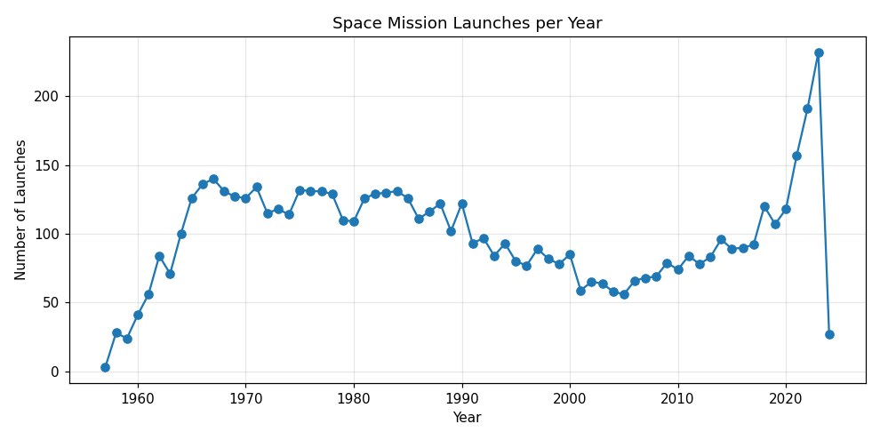
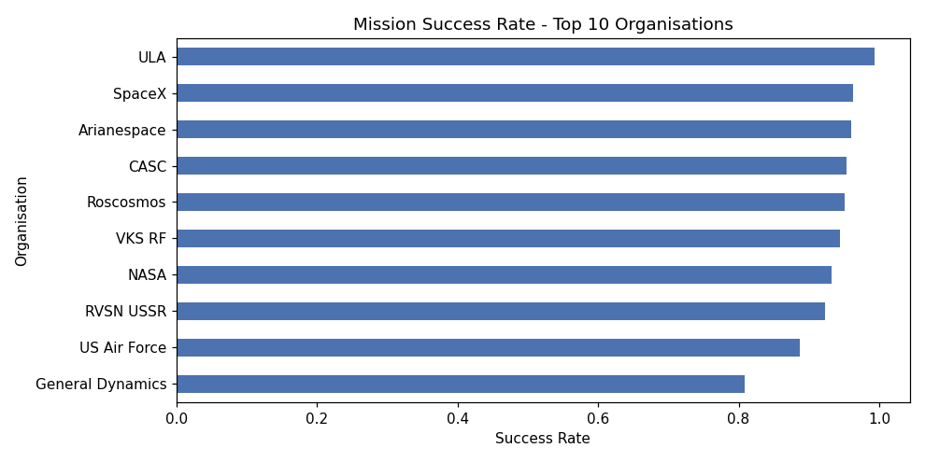
Accuracy: 0.9144

Classification Report:
precision recall f1-score support

Failure 0.50 0.30 0.37 115
Success 0.94 0.97 0.95 1228

accuracy 0.91 1343
macro avg 0.72 0.63 0.66 1343
weighted avg 0.90 0.91 0.90 1343

Confusion Matrix:
[[ 34 81]
[ 34 1194]]
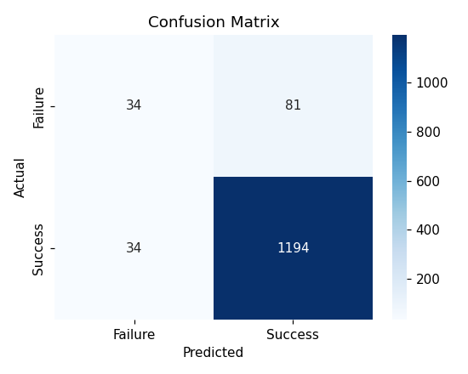
Feature Importance:
Year 0.514887
Rocket_Name 0.281975
Organisation 0.088506
Country 0.064119
Price 0.041299
Rocket_Status 0.009214
dtype: float64

Analysis completed successfully!
RESULT:
Thus, the Space Mission dataset was analyzed using Exploratory Data Analysis, the launch patterns were visualized, a Random Forest Classifier was built and evaluated to predict the mission status with an accuracy of 91.44%, and the processed data was exported to an Excel file successfully.

